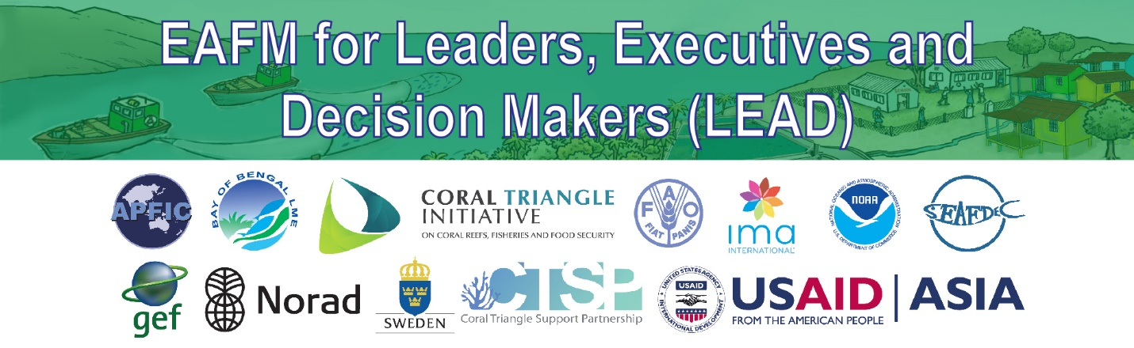

EAFM High-level Consultation for Leaders,
Executives and Decision Makers (LEAD)
1-Day Consultation Outline

Objective: In a one-day high level consultation (HLC), provide opportunities for leaders, executives and decision-makers (LEADers) to understand and support the Ecosystem Approach to Fisheries Management (EAFM) to achieve sustainable fisheries through improved holistic planning and implementation.
Audience: A small number of middle managers (up to 30) that will be future Leaders, executives and decision-makers (LEADers) in the fisheries and other sectors (i.e. agriculture, forestry, academia, private, NGOs) and throughout levels of government from national to community (including traditional leaders). The LEADers will need to commit to a full day for the Consultation.

Facilitators: Minimum 2 people plus support staff (recommend including well-known/well respected master of ceremony (MC)). Facilitators must have experience and knowledge of EAFM in the nation/region, be trusted and respected by leaders, have the ability to communicate well in relevant languages (possibly supported by a translator fluent in the EAFM vocabulary).

Output: Expressed commitment and action plans for next steps in moving toward EAFM (individual, agency, country).

1-day LEAD Process:
The 1-day LEAD consultation is planned to cover the following sessions and objectives:

I. Opening and introductions
To introduce participants and facilitators, set the stage on what will be covered and how the consultation will be conducted.

II. Threats, issues, and vision for the future
To begin thinking more holistically beyond fisheries and in the broader development context and envisage the future.

III. Overview of EAFM: What and why EAFM
To understand why EAFM is needed for sustainable fisheries and development, what EAFM is, and to recognize how much EAFM is already being carried out.

IV. National roles, responsibilities, and existing frameworks
To recognize that global/regional frameworks support EAFM and that national legislation also often supports an ecosystem approach.

V. Linking policies to action and importance of EAFM plans
To recognize that EAFM plans are needed to link policy to management actions and that EAFM needs to be included in national/ provincial/ district long term plans.

VI. EAFM planning process
To introduce the EAFM management cycle and the EAFM planning process.

VII. Policy trade-offs
To understand that in looking at the broader ecosystem interactions, policy tradeoffs may be needed.

VIII. EAFM governance frameworks
To understand the importance of having effective governance framework in place and supported by a functional fisheries management infrastructure.

IX. Developing capacity for EAFM
To encourage participants to support their staff/agency, influence their leaders and leaders of other sectors to develop capacity in EAFM.

X. Next steps and action plans
- To identify challenges, opportunities, and benefits for country/locality in moving toward EAFM
- To agree on next steps, including action plans, for individuals, agencies and countries in moving toward EAFM.

XI. Closing

